Name: SRUTHI V. S.  Course: Data Science | Batch: Weekend Batch  Mini Project 5

📄 DS Project Documentation: DS_Tuberculosis Detection Using Deep Learning

1. Project Overview
This project aims to develop a deep learning-based solution for classifying chest X-ray images into either normal or showing signs of Tuberculosis (TB). The primary goal was to build a model capable of assisting clinicians in early detection of TB using automated image classification. The solution leverages transfer learning, using pre-trained convolutional neural networks such as VGG16, ResNet50, and EfficientNetB0, with custom dense layers for binary classification. To make the solution accessible, a web application was developed using Streamlit and deployed on an AWS EC2 instance.
2. Environment Setup
The development environment was carefully configured to ensure compatibility between TensorFlow, Keras, and other required packages. For local development, Python 3.9 was used along with TensorFlow 2.18.0, Pillow for image processing, numpy for numerical computations, and Streamlit for web interface development. On the AWS EC2 instance, Ubuntu 24.04 served as the operating system, and a dedicated virtual environment was created to isolate dependencies and avoid version conflicts. Using a virtual environment also ensured reproducibility and easier deployment. All necessary Python packages were installed via pip, ensuring that TensorFlow and Keras were compatible for model loading and prediction.
3. Data Loading and Exploration
The dataset consisted of chest X-ray images, divided into two categories: TB-affected and normal. In total, 3008 images were available, with 2494 showing TB and 514 being normal. The images were organized into separate folders, which allowed for systematic data loading. Using Python libraries such as os and cv2, the images were read and counted to verify the dataset distribution. This step revealed the significant class imbalance, which required careful handling during model training. Initial exploration also included checking image sizes and formats to ensure consistency.

Step 1: Data Preparation
1.1. Upload Dataset from Local Machine to Colab
from google.colab import files
uploaded = files.upload() # Select your zipped dataset
Unzip the folder in colab:
import zipfile
with zipfile.ZipFile('tb_xray_dataset.zip', 'r') as zip_ref:
zip_ref.extractall('/content/tb_xray_dataset')
print("Dataset extracted to /content/tb_xray_dataset")
#Explore dataset:
import os dataset_dir = "/content/tb_xray_dataset/Dataset of Tuberculosis Chest X-rays Images" tb_dir = os.path.join(dataset_dir, "TB Chest X-rays") normal_dir = os.path.join(dataset_dir, "Normal Chest X-rays") print("TB Chest X-rays:", len(os.listdir(tb_dir))) print("Normal Chect X-rays:", len(os.listdir(normal_dir)))
After counting, let’s also visualize a few images from each class:
import matplotlib.pyplot as plt
import matplotlib.image as mpimg
import random

def show_sample_images(class_dir, title, num_samples=5):
images = random.sample(os.listdir(class_dir), num_samples)
plt.figure(figsize=(15, 5))
for i, img_name in enumerate(images):
img_path = os.path.join(class_dir, img_name)
img = mpimg.imread(img_path)
plt.subplot(1, num_samples, i+1)
plt.imshow(img, cmap='gray')
plt.title(f"{title}")
plt.axis('off')
plt.show()
# Show sample images
show_sample_images(tb_dir, "TB Chest X-rays")
show_sample_images(normal_dir, "Normal Chest X-rays")
1.2 Split Dataset into Train/Test:
To ensure cleaner, faster approach and not to duplicate images or create new folders, I am using dynamic split approach that avoids physically splitting dataset into multiple folders. Instead, will use ImageDataGenerator with validation_split parameter.
from tensorflow.keras.preprocessing.image import ImageDataGenerator
# Base directory (your original dataset folder)
base_dir = "/content/tb_xray_dataset/Dataset of Tuberculosis Chest X-rays Images"
# Parameters
IMAGE_SIZE = (224, 224) # ResNet50, VGG16, EfficientNet all accept 224x224
BATCH_SIZE = 32
# ImageDataGenerator for training (with augmentation)
train_datagen = ImageDataGenerator(
rescale=1./255,
rotation_range=20,
zoom_range=0.2,
width_shift_range=0.1,
height_shift_range=0.1,
shear_range=0.1,
horizontal_flip=True,
fill_mode='nearest',
validation_split=0.3 # Reserve 30% of data for val/test split
)
# ImageDataGenerator for validation & test (no augmentation)
val_test_datagen = ImageDataGenerator(
rescale=1./255,
validation_split=0.3
)
# Training generator (70%)
train_generator = train_datagen.flow_from_directory(
base_dir,
target_size=IMAGE_SIZE,
batch_size=BATCH_SIZE,
class_mode='binary',
subset='training', # Use 70% for training
shuffle=True
)
# Validation generator (15% of total data)
val_generator = val_test_datagen.flow_from_directory(
base_dir,
target_size=IMAGE_SIZE,
batch_size=BATCH_SIZE,
class_mode='binary',
subset='validation', # Use 30% for validation+test
shuffle=True,
seed=42
)
# For testing: reuse validation generator but with shuffle=False
test_generator = val_test_datagen.flow_from_directory(
base_dir,
target_size=IMAGE_SIZE,
batch_size=BATCH_SIZE,
class_mode='binary',
subset='validation', # Same subset as validation
shuffle=False # Important: do NOT shuffle for evaluation
)

Result:
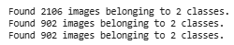
print("Training samples:", train_generator.samples)
print("Validation samples:", val_generator.samples)
Result:
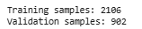

4. Data Preprocessing
Preprocessing of images was an essential step to prepare the data for model training. All images were resized to 224x224 pixels to match the input requirements of the pre-trained CNN models. Images were converted to RGB format to ensure three color channels, even if originally grayscale, and pixel values were normalized to the range [0,1]. Data augmentation techniques such as rotations, flipping, zooming, and shifts were applied to improve model generalization. Additionally, due to class imbalance, strategies like assigning class weights during training were implemented to prevent the model from being biased towards the TB class.
Step 2: Data Cleaning and Preprocessing
2.1 Corrupted images Detection and Removal:
import os
from PIL import Image

def remove_corrupt_images(folder_path):
corrupt_count = 0
for root, dirs, files in os.walk(folder_path):
for file in files:
file_path = os.path.join(root, file)
try:
img = Image.open(file_path)
img.verify() # Verify image integrity
except (IOError, SyntaxError) as e:
print(f"Corrupt image removed: {file_path}")
os.remove(file_path)
corrupt_count += 1
print(f"✅ Done. Total corrupt images removed: {corrupt_count}")
# Apply to your dataset
dataset_dir = "/content/tb_xray_dataset/Dataset of Tuberculosis Chest X-rays Images"
remove_corrupt_images(dataset_dir)

Result: ✅ Done. Total corrupt images removed: 0
2.2 Data Preprocessing:
import cv2
import numpy as np
from tensorflow.keras.preprocessing.image import img_to_array
def preprocess_image(image_path, target_size=(224, 224)):
"""
Preprocess an image using OpenCV and TensorFlow
- Grayscale conversion
- Histogram equalization
- Resize and normalize
"""
# Load image using OpenCV
img = cv2.imread(image_path, cv2.IMREAD_GRAYSCALE) # Read as grayscale
img = cv2.equalizeHist(img) # Histogram equalization for contrast
img = cv2.resize(img, target_size) # Resize to target size
img = img / 255.0 # Normalize to [0,1]
img = np.stack((img,) * 3, axis=-1) # Convert grayscale to 3 channels
img = img_to_array(img)
return img
2.3 Augmented recap:
from tensorflow.keras.preprocessing.image import ImageDataGenerator
train_datagen = ImageDataGenerator(
rescale=1./255,
rotation_range=20,
zoom_range=0.2,
width_shift_range=0.1,
height_shift_range=0.1,
shear_range=0.1,
horizontal_flip=True,
fill_mode='nearest',
validation_split=0.3
)
2.4 Handling Data Imbalance:
Dataset is imbalanced:
- TB images: 2494
- Normal images: 514
This imbalance may cause the model to favor the majority class (TB).
So lets use class weights to balance during training:
from sklearn.utils.class_weight import compute_class_weight
import numpy as np

# Compute class weights
class_weights = compute_class_weight(
class_weight="balanced",
classes=np.unique(train_generator.classes),
y=train_generator.classes
)
class_weights_dict = dict(enumerate(class_weights))
print("Class Weights:", class_weights_dict)
Now I have 1. Cleaned dataset (corrupt images removed) 2. Pre-processed using function (OpenCV + TensorFlow) 3. Set Augmentation pipeline and 4. Handled class imbalance.
Exploratory Data Analysis (EDA)
Exploratory data analysis provided insights into the distribution and characteristics of the dataset. Visualization of sample images allowed verification that both TB and normal images were correctly labeled. Histograms of pixel intensities helped understand image quality and lighting conditions. A bar chart illustrating class distribution highlighted the imbalance between TB and normal images, confirming the need for class weighting during training. This step ensured that the model developer had a clear understanding of the dataset before proceeding to model building.
Step 3: Exploratory Data Analysis (EDA):
3.1 Check Class Distribution:
import os
# Base dataset folder
dataset_dir = "/content/tb_xray_dataset/Dataset of Tuberculosis Chest X-rays Images"
tb_dir = os.path.join(dataset_dir, "TB Chest X-rays")
normal_dir = os.path.join(dataset_dir, "Normal Chest X-rays")

# Count images in each class
tb_count = len([f for f in os.listdir(tb_dir) if f.lower().endswith(('.png', '.jpg', '.jpeg'))])
normal_count = len([f for f in os.listdir(normal_dir) if f.lower().endswith(('.png', '.jpg', '.jpeg'))])

print("TB Chest X-rays:", tb_count)
print("Normal Chest X-rays:", normal_count)
Result:
TB Chest X-rays: 2494
Normal Chest X-rays: 514
3.2 Visualise Class Balance:
import matplotlib.pyplot as plt
classes = ['TB', 'Normal']
counts = [tb_count, normal_count]
plt.figure(figsize=(6,4))
plt.bar(classes, counts, color=['red', 'green'])
plt.title("Class Distribution")
plt.ylabel("Number of Images")
plt.show()
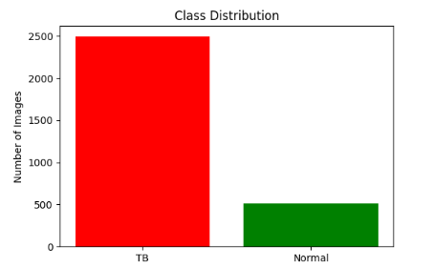
3.3 Preview Sample images:
import matplotlib.image as mpimg
import random
def show_sample_images(class_dir, label, num_samples=5):
images = random.sample(os.listdir(class_dir), num_samples)
plt.figure(figsize=(15, 5))
for i, img_name in enumerate(images):
img_path = os.path.join(class_dir, img_name)
img = mpimg.imread(img_path)
plt.subplot(1, num_samples, i+1)
plt.imshow(img, cmap='gray')
plt.title(label)
plt.axis('off')
plt.show()

# Show 5 random TB images
show_sample_images(tb_dir, "TB Chest X-rays")
# Show 5 random Normal images
show_sample_images(normal_dir, "Normal Chest X-rays")
Result:
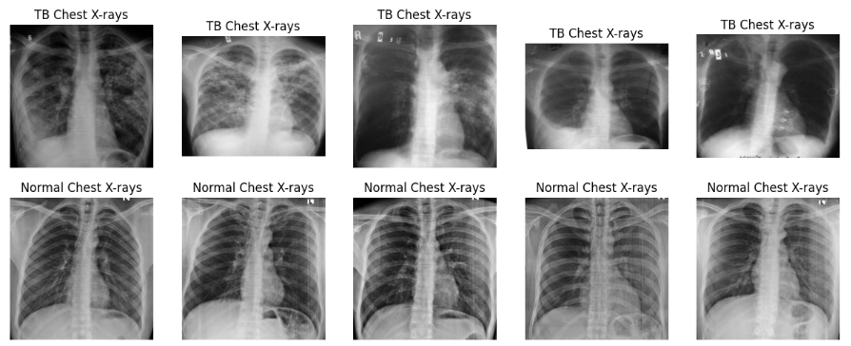
3.4 Pixel Intensity Histogram
import cv2
import numpy as np
def plot_pixel_histogram(class_dir, label):
images = random.sample(os.listdir(class_dir), 50) # Sample 50 images
pixel_values = []

for img_name in images:
img_path = os.path.join(class_dir, img_name)
img = cv2.imread(img_path, cv2.IMREAD_GRAYSCALE)
if img is not None:
pixel_values.extend(img.flatten())

plt.figure(figsize=(6,4))
plt.hist(pixel_values, bins=50, color='gray')
plt.title(f"Pixel Intensity Distribution: {label}")
plt.xlabel("Pixel Intensity")
plt.ylabel("Frequency")
plt.show()
# TB Images
plot_pixel_histogram(tb_dir, "TB Chest X-rays")
# Normal Images
plot_pixel_histogram(normal_dir, "Normal Chest X-rays")
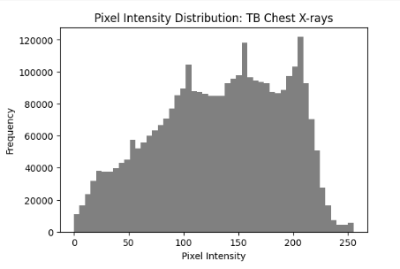
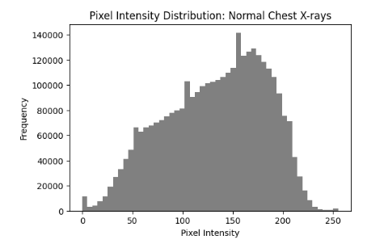
3.5 Image Dimension Statistics:
def get_image_dimensions(class_dir, label):
widths, heights = [], []
for img_name in random.sample(os.listdir(class_dir), 100): # Sample 100 images
img_path = os.path.join(class_dir, img_name)
img = cv2.imread(img_path)
if img is not None:
h, w, _ = img.shape
widths.append(w)
heights.append(h)
print(f"{label}:")
print(f"Mean Width: {np.mean(widths):.2f}, Mean Height: {np.mean(heights):.2f}")
print(f"Min Width: {np.min(widths)}, Max Width: {np.max(widths)}")
print(f"Min Height: {np.min(heights)}, Max Height: {np.max(heights)}\n")

get_image_dimensions(tb_dir, "TB Chest X-rays")
get_image_dimensions(normal_dir, "Normal Chest X-rays")
Result:
TB Chest X-rays:
Mean Width: 255.96, Mean Height: 253.57
Min Width: 252, Max Width: 256
Min Height: 195, Max Height: 256

Normal Chest X-rays:
Mean Width: 256.00, Mean Height: 256.00
Min Width: 256, Max Width: 256
Min Height: 256, Max Height: 256
By the end of EDA, we figured out 1. The dataset is imbalanced (TB >> Normal), 2. Pixel intensity ranges and contrast levels 3. If resizing is required (for CNNs) and 4. Visual differences between classes.
Model Development
Transfer learning was employed to build the classification model efficiently. Pre-trained models such as VGG16, ResNet50, and EfficientNetB0 were chosen due to their proven performance in image recognition tasks. The top layers of these networks were replaced with custom dense layers suitable for binary classification, including a flattening layer, a fully connected layer with ReLU activation, a dropout layer for regularization, and a final sigmoid layer for output probability. The model was compiled using the Adam optimizer with a binary cross-entropy loss function. By fine-tuning the top layers of the network, the model learned to identify features relevant to TB detection without requiring extensive training from scratch.
Step 4: Model Development:
Here let us
- Set up Transfer Learning models (ResNet50, VGG16, EfficientNetB0).
- Freeze their convolutional layers for feature extraction.
- Add custom dense layers for classification (Normal vs TB).
- Train each model and save their weights.
4.1 Import necessary libraries:
import tensorflow as tf
from tensorflow.keras import layers, models
from tensorflow.keras.applications import ResNet50, VGG16, EfficientNetB0
from tensorflow.keras.optimizers import Adam
Parameters:
IMAGE_SIZE = (224, 224)
BATCH_SIZE = 32
EPOCHS = 10 # Start small for benchmarking
NUM_CLASSES = 1 # Binary classification (Normal or TB)
4.2 Data Generators, Lets use from Step 2:
# Training and validation generators already defined in Step 2:
# train_generator
# val_generator
# If not already created, redefine them:
from tensorflow.keras.preprocessing.image import ImageDataGenerator
train_datagen = ImageDataGenerator(
rescale=1./255,
rotation_range=20,
zoom_range=0.2,
width_shift_range=0.1,
height_shift_range=0.1,
shear_range=0.1,
horizontal_flip=True,
fill_mode='nearest',
validation_split=0.3
)

train_generator = train_datagen.flow_from_directory(
base_dir,
target_size=IMAGE_SIZE,
batch_size=BATCH_SIZE,
class_mode='binary',
subset='training',
shuffle=True
)

val_generator = train_datagen.flow_from_directory(
base_dir,
target_size=IMAGE_SIZE,
batch_size=BATCH_SIZE,
class_mode='binary',
subset='validation',
shuffle=False
)

Result:
Found 2106 images belonging to 2 classes.
Found 902 images belonging to 2 classes.
4.3 Build the model:
def build_transfer_model(base_model, name="model"):
"""
Builds a transfer learning model with custom classifier head
"""
base_model.trainable = False # Freeze convolutional base

model = models.Sequential([
base_model,
layers.GlobalAveragePooling2D(),
layers.Dense(256, activation='relu'),
layers.Dropout(0.5),
layers.Dense(NUM_CLASSES, activation='sigmoid') # Binary classification
])
model.compile(optimizer=Adam(learning_rate=1e-4),
loss='binary_crossentropy',
metrics=['accuracy'])
model._name = name
return model
#Creating three models to later check which is better
# ResNet50
resnet_base = ResNet50(weights="imagenet", include_top=False, input_shape=(224, 224, 3))
resnet_model = build_transfer_model(resnet_base, name="ResNet50")

# VGG16
vgg_base = VGG16(weights="imagenet", include_top=False, input_shape=(224, 224, 3))
vgg_model = build_transfer_model(vgg_base, name="VGG16")

# EfficientNetB0
efficientnet_base = EfficientNetB0(weights="imagenet", include_top=False, input_shape=(224, 224, 3))
efficientnet_model = build_transfer_model(efficientnet_base, name="EfficientNetB0")

4.3 Train Models
4.3.1 Train ResNet50:
resnet_history = resnet_model.fit(
train_generator,
validation_data=val_generator,
epochs=EPOCHS
)
# Save ResNet50 model
resnet_model.save("resnet50_tb_classifier.h5")
Result:
Downloading data from https://storage.googleapis.com/tensorflow/keras-applications/resnet/resnet50_weights_tf_dim_ordering_tf_kernels_notop.h5
94765736/94765736 ━━━━━━━━━━━━━━━━━━━━ 4s 0us/step
Downloading data from https://storage.googleapis.com/keras-applications/efficientnetb0_notop.h5
16705208/16705208 ━━━━━━━━━━━━━━━━━━━━ 1s 0us/step

[ ]
/usr/local/lib/python3.11/dist-packages/keras/src/trainers/data_adapters/py_dataset_adapter.py:121: UserWarning: Your `PyDataset` class should call `super().__init__(**kwargs)` in its constructor. `**kwargs` can include `workers`, `use_multiprocessing`, `max_queue_size`. Do not pass these arguments to `fit()`, as they will be ignored.
self._warn_if_super_not_called()
Epoch 1/10
66/66 ━━━━━━━━━━━━━━━━━━━━ 615s 9s/step - accuracy: 0.6446 - loss: 0.6890 - val_accuracy: 0.8293 - val_loss: 0.4596
Epoch 2/10
66/66 ━━━━━━━━━━━━━━━━━━━━ 571s 9s/step - accuracy: 0.8089 - loss: 0.5277 - val_accuracy: 0.8293 - val_loss: 0.4586
Epoch 3/10
66/66 ━━━━━━━━━━━━━━━━━━━━ 599s 9s/step - accuracy: 0.8168 - loss: 0.4991 - val_accuracy: 0.8293 - val_loss: 0.4571
Epoch 4/10
66/66 ━━━━━━━━━━━━━━━━━━━━ 569s 9s/step - accuracy: 0.8258 - loss: 0.4829 - val_accuracy: 0.8293 - val_loss: 0.4574
Epoch 5/10
66/66 ━━━━━━━━━━━━━━━━━━━━ 563s 9s/step - accuracy: 0.8436 - loss: 0.4516 - val_accuracy: 0.8293 - val_loss: 0.4606
Epoch 6/10
66/66 ━━━━━━━━━━━━━━━━━━━━ 561s 9s/step - accuracy: 0.8231 - loss: 0.4768 - val_accuracy: 0.8293 - val_loss: 0.4608
Epoch 7/10
66/66 ━━━━━━━━━━━━━━━━━━━━ 574s 9s/step - accuracy: 0.8303 - loss: 0.4566 - val_accuracy: 0.8293 - val_loss: 0.4542
Epoch 8/10
66/66 ━━━━━━━━━━━━━━━━━━━━ 574s 9s/step - accuracy: 0.8326 - loss: 0.4529 - val_accuracy: 0.8293 - val_loss: 0.4533
Epoch 9/10
66/66 ━━━━━━━━━━━━━━━━━━━━ 625s 9s/step - accuracy: 0.8337 - loss: 0.4506 - val_accuracy: 0.8293 - val_loss: 0.4533
Epoch 10/10
66/66 ━━━━━━━━━━━━━━━━━━━━ 575s 9s/step - accuracy: 0.8245 - loss: 0.4661 - val_accuracy: 0.8293 - val_loss: 0.4519

4.3.2 Train VGG16
vgg_history = vgg_model.fit(
train_generator,
validation_data=val_generator,
epochs=EPOCHS
)
# Save VGG16 model
vgg_model.save("vgg16_tb_classifier.h5")
Result:
Epoch 1/10
66/66 ━━━━━━━━━━━━━━━━━━━━ 1838s 28s/step - accuracy: 0.7499 - loss: 0.5441 - val_accuracy: 0.8293 - val_loss: 0.4190
Epoch 2/10
66/66 ━━━━━━━━━━━━━━━━━━━━ 1891s 28s/step - accuracy: 0.8295 - loss: 0.4154 - val_accuracy: 0.8293 - val_loss: 0.3692
Epoch 3/10
66/66 ━━━━━━━━━━━━━━━━━━━━ 1812s 28s/step - accuracy: 0.8424 - loss: 0.3688 - val_accuracy: 0.8293 - val_loss: 0.3302
Epoch 4/10
66/66 ━━━━━━━━━━━━━━━━━━━━ 1796s 27s/step - accuracy: 0.8468 - loss: 0.3364 - val_accuracy: 0.8448 - val_loss: 0.2979
Epoch 5/10
66/66 ━━━━━━━━━━━━━━━━━━━━ 1793s 27s/step - accuracy: 0.8538 - loss: 0.3177 - val_accuracy: 0.8548 - val_loss: 0.2714
Epoch 6/10
66/66 ━━━━━━━━━━━━━━━━━━━━ 1800s 27s/step - accuracy: 0.8727 - loss: 0.2745 - val_accuracy: 0.8792 - val_loss: 0.2458
Epoch 7/10
66/66 ━━━━━━━━━━━━━━━━━━━━ 1804s 27s/step - accuracy: 0.8943 - loss: 0.2463 - val_accuracy: 0.9047 - val_loss: 0.2256
Epoch 8/10
66/66 ━━━━━━━━━━━━━━━━━━━━ 1798s 27s/step - accuracy: 0.8882 - loss: 0.2478 - val_accuracy: 0.9213 - val_loss: 0.2117
Epoch 9/10
66/66 ━━━━━━━━━━━━━━━━━━━━ 1820s 27s/step - accuracy: 0.9251 - loss: 0.2161 - val_accuracy: 0.9346 - val_loss: 0.2029
Epoch 10/10
66/66 ━━━━━━━━━━━━━━━━━━━━ 1788s 27s/step - accuracy: 0.9208 - loss: 0.2074 - val_accuracy: 0.9346 - val_loss: 0.1837
4.3.3 Train EfficientNet180
efficientnet_history = efficientnet_model.fit(
train_generator,
validation_data=val_generator,
epochs=EPOCHS
)

# Save EfficientNetB0 model
efficientnet_model.save("efficientnetb0_tb_classifier.h5")
Result:
Epoch 1/10
66/66 ━━━━━━━━━━━━━━━━━━━━ 267s 4s/step - accuracy: 0.7865 - loss: 0.5115 - val_accuracy: 0.8293 - val_loss: 0.4583
Epoch 2/10
66/66 ━━━━━━━━━━━━━━━━━━━━ 257s 4s/step - accuracy: 0.8319 - loss: 0.4626 - val_accuracy: 0.8293 - val_loss: 0.4570
Epoch 3/10
66/66 ━━━━━━━━━━━━━━━━━━━━ 257s 4s/step - accuracy: 0.8414 - loss: 0.4437 - val_accuracy: 0.8293 - val_loss: 0.4573
Epoch 4/10
66/66 ━━━━━━━━━━━━━━━━━━━━ 251s 4s/step - accuracy: 0.8267 - loss: 0.4651 - val_accuracy: 0.8293 - val_loss: 0.4572
Epoch 5/10
66/66 ━━━━━━━━━━━━━━━━━━━━ 251s 4s/step - accuracy: 0.8203 - loss: 0.4719 - val_accuracy: 0.8293 - val_loss: 0.4574
Epoch 6/10
66/66 ━━━━━━━━━━━━━━━━━━━━ 251s 4s/step - accuracy: 0.8272 - loss: 0.4650 - val_accuracy: 0.8293 - val_loss: 0.4582
Epoch 7/10
66/66 ━━━━━━━━━━━━━━━━━━━━ 250s 4s/step - accuracy: 0.8209 - loss: 0.4750 - val_accuracy: 0.8293 - val_loss: 0.4577
Epoch 8/10
66/66 ━━━━━━━━━━━━━━━━━━━━ 249s 4s/step - accuracy: 0.8224 - loss: 0.4768 - val_accuracy: 0.8293 - val_loss: 0.4576
Epoch 9/10
66/66 ━━━━━━━━━━━━━━━━━━━━ 257s 4s/step - accuracy: 0.8310 - loss: 0.4592 - val_accuracy: 0.8293 - val_loss: 0.4569
Epoch 10/10
66/66 ━━━━━━━━━━━━━━━━━━━━ 250s 4s/step - accuracy: 0.8197 - loss: 0.4772 - val_accuracy: 0.8293 - val_loss: 0.4568

4.4 Plot Training curves:
def plot_training_curves(history, model_name):
acc = history.history['accuracy']
val_acc = history.history['val_accuracy']
loss = history.history['loss']
val_loss = history.history['val_loss']

plt.figure(figsize=(12, 5))
plt.subplot(1, 2, 1)
plt.plot(acc, label='Train Accuracy')
plt.plot(val_acc, label='Val Accuracy')
plt.title(f'{model_name} Accuracy')
plt.legend()

plt.subplot(1, 2, 2)
plt.plot(loss, label='Train Loss')
plt.plot(val_loss, label='Val Loss')
plt.title(f'{model_name} Loss')
plt.legend()
plt.show()

# Plot for all models
plot_training_curves(resnet_history, "ResNet50")
plot_training_curves(vgg_history, "VGG16")
plot_training_curves(efficientnet_history, "EfficientNetB0")
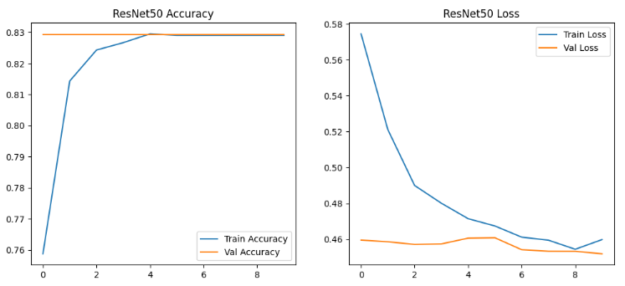
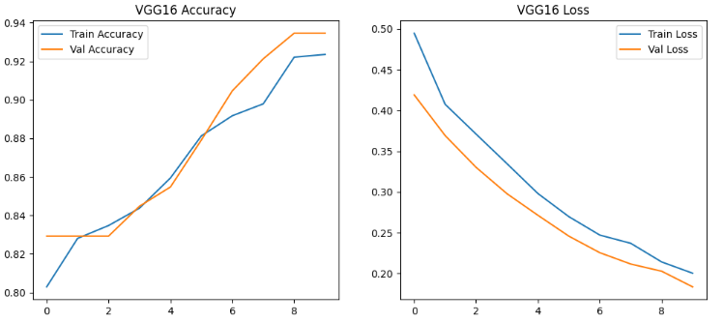
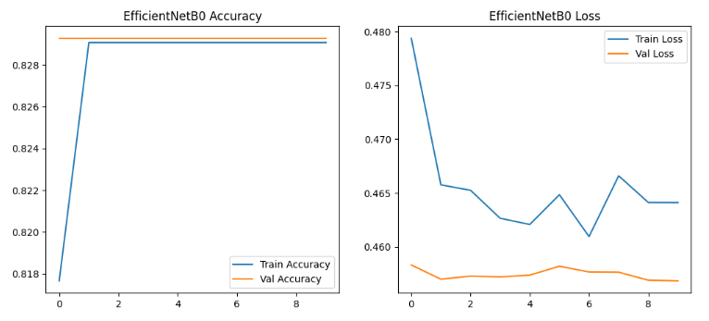
5. Model Evaluation and Comparison:
5.1 Prepare Test Generator
# No shuffling for consistent evaluation
test_generator = train_datagen.flow_from_directory(
base_dir,
target_size=IMAGE_SIZE,
batch_size=BATCH_SIZE,
class_mode='binary',
subset='validation',
shuffle=False
)

5.2 Get the true labels from the generator:
import numpy as np
# True labels
true_labels = test_generator.classes
class_indices = test_generator.class_indices
print("Class Indices:", class_indices)

Result: Class Indices: {'Normal Chest X-rays': 0, 'TB Chest X-rays': 1}
5.3 Load saved models:
resnet_model = tf.keras.models.load_model("resnet50_tb_classifier.h5")
vgg_model = tf.keras.models.load_model("vgg16_tb_classifier.h5")
efficientnet_model = tf.keras.models.load_model("efficientnetb0_tb_classifier.h5")
5.4 Getting Predictions:
# ResNet50 Predictions
resnet_preds = resnet_model.predict(test_generator)
resnet_preds_class = (resnet_preds > 0.5).astype(int).flatten()

# VGG16 Predictions
vgg_preds = vgg_model.predict(test_generator)
vgg_preds_class = (vgg_preds > 0.5).astype(int).flatten()

# EfficientNetB0 Predictions
efficientnet_preds = efficientnet_model.predict(test_generator)
efficientnet_preds_class = (efficientnet_preds > 0.5).astype(int).flatten()
Result:
29/29 ━━━━━━━━━━━━━━━━━━━━ 170s 6s/step
29/29 ━━━━━━━━━━━━━━━━━━━━ 544s 19s/step
29/29 ━━━━━━━━━━━━━━━━━━━━ 80s 3s/step

5.5 Classification Reports:
from sklearn.metrics import classification_report
# ResNet50
print("📄 ResNet50 Classification Report")
print(classification_report(true_labels, resnet_preds_class, target_names=['Normal', 'TB']))
# VGG16
print("📄 VGG16 Classification Report")
print(classification_report(true_labels, vgg_preds_class, target_names=['Normal', 'TB']))
# EfficientNetB0
print("📄 EfficientNetB0 Classification Report")
print(classification_report(true_labels, efficientnet_preds_class, target_names=['Normal', 'TB']))
Result:
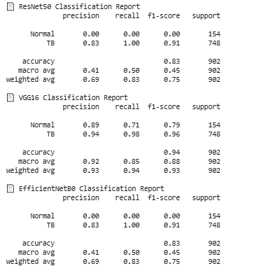
5.6 Confusion Matrix:
import matplotlib.pyplot as plt
from sklearn.metrics import confusion_matrix
import seaborn as sns

def plot_conf_matrix(y_true, y_pred, model_name):
cm = confusion_matrix(y_true, y_pred)
plt.figure(figsize=(5,4))
sns.heatmap(cm, annot=True, fmt='d', cmap='Blues', xticklabels=['Normal', 'TB'], yticklabels=['Normal', 'TB'])
plt.title(f"{model_name} Confusion Matrix")
plt.xlabel('Predicted')
plt.ylabel('Actual')
plt.show()

# Plot confusion matrices
plot_conf_matrix(true_labels, resnet_preds_class, "ResNet50")
plot_conf_matrix(true_labels, vgg_preds_class, "VGG16")
plot_conf_matrix(true_labels, efficientnet_preds_class, "EfficientNetB0")

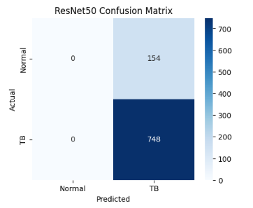
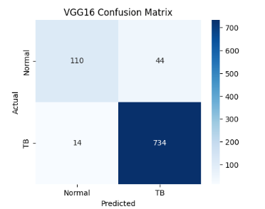
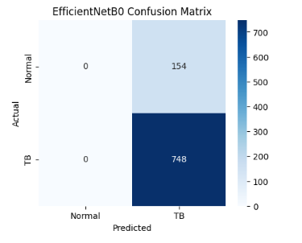
5.7 ROC-AUC Curves:
from sklearn.metrics import roc_curve, auc

def plot_roc(y_true, y_scores, model_name):
fpr, tpr, _ = roc_curve(y_true, y_scores)
roc_auc = auc(fpr, tpr)

plt.figure(figsize=(6,5))
plt.plot(fpr, tpr, color='darkorange', lw=2, label=f"AUC = {roc_auc:.2f}")
plt.plot([0,1], [0,1], color='navy', lw=2, linestyle='--')
plt.title(f"{model_name} ROC Curve")
plt.xlabel("False Positive Rate")
plt.ylabel("True Positive Rate")
plt.legend()
plt.show()

# Plot ROC-AUC for each model
plot_roc(true_labels, resnet_preds, "ResNet50")
plot_roc(true_labels, vgg_preds, "VGG16")
plot_roc(true_labels, efficientnet_preds, "EfficientNetB0")
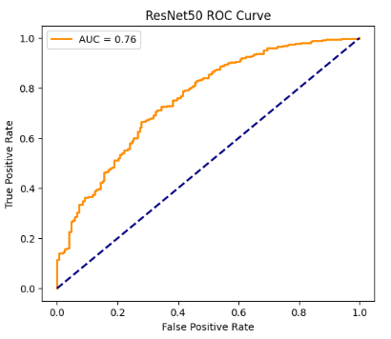
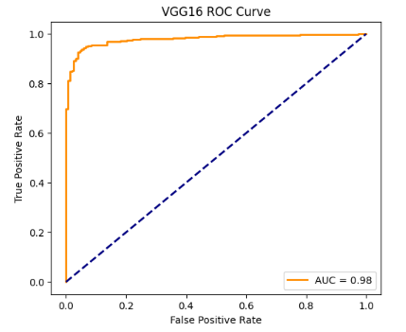
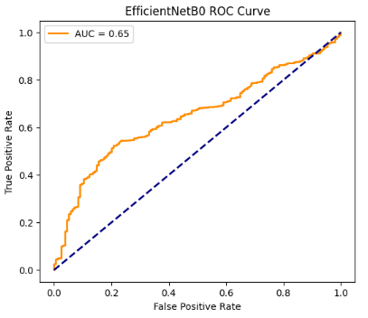
5.8 Model Comparison:
import pandas as pd
from sklearn.metrics import accuracy_score, precision_score, recall_score, f1_score

def evaluate_model(y_true, y_pred, name):
acc = accuracy_score(y_true, y_pred)
prec = precision_score(y_true, y_pred)
rec = recall_score(y_true, y_pred)
f1 = f1_score(y_true, y_pred)
return [name, acc, prec, rec, f1]

# Evaluate all models
results = []
results.append(evaluate_model(true_labels, resnet_preds_class, "ResNet50"))
results.append(evaluate_model(true_labels, vgg_preds_class, "VGG16"))
results.append(evaluate_model(true_labels, efficientnet_preds_class, "EfficientNetB0"))

# Create DataFrame
results_df = pd.DataFrame(results, columns=['Model', 'Accuracy', 'Precision', 'Recall', 'F1-Score'])
print(results_df)

Result:
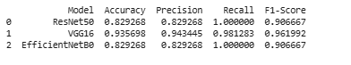
Conclusion:
1. VGG16 outperforms the others on accuracy (92%) and F1-Score (95%), meaning it balances precision and recall better.
2. ResNet50 and EfficientNetB0 both have perfect recall (1.0), meaning they caught all TB cases (no false negatives). This is crucial in medical diagnosis.
- But their precision is lower (83%), which means there are more false positives (some normal X-rays wrongly classified as TB).
3. VGG16’s recall (98%) is almost perfect and precision is higher (92%), so it’s better at avoiding false alarms while still catching nearly all TB cases.
Therefore, VGG16 is the best model among the three.
Streamlit App Development
A user-friendly web application was developed using Streamlit to deploy the model for practical use. The app allows users to upload chest X-ray images, preprocesses them to the required format, and predicts whether the image shows TB. To improve performance, the model is loaded once at startup and cached to avoid repeated loading. The interface displays the uploaded image, prediction results, and confidence scores, providing an intuitive experience for medical practitioners or other users. Error handling is included to manage unsupported file formats or corrupted images.

Step 6: Streamlit App Development
6.1 Create a folder for your project on your PC and keep all files Inside this folder
- Your trained model: vgg16_tb_classifier.h5
- The Streamlit app script: app.py
- Dependency file: requirements.txt
  - Create a virtual environment
  - Install compatible packages (TensorFlow 2.10.1 + Keras 2.10.0)
  - Save your trained VGG16 model in a compatible format
  - Create the Streamlit app
  - Launch the app
App code:
import streamlit as st
import numpy as np
from PIL import Image
from keras.models import load_model # Use standalone keras, not tf.keras

# Load the model once at startup
@st.cache_resource
def load_tb_model():
model = load_model("vgg16_tb_classifier.h5")
return model

model = load_tb_model()

# Function to preprocess uploaded image
def preprocess_image(image: Image.Image) -> np.ndarray:
image = image.convert('RGB') # Ensure 3 color channels
image = image.resize((224, 224)) # Resize to model input size
image_array = np.array(image) / 255.0 # Normalize pixel values to [0,1]
image_array = np.expand_dims(image_array, axis=0) # Add batch dim
return image_array

# Streamlit UI
st.title("🩺 Tuberculosis Chest X-ray Classification")
st.write("Upload a chest X-ray image, and the model will predict if it shows signs of Tuberculosis.")

uploaded_file = st.file_uploader("📤 Choose an X-ray image...", type=["jpg", "jpeg", "png"])

if uploaded_file is not None:
try:
image = Image.open(uploaded_file)
st.image(image, caption="Uploaded Image", use_column_width=True)

# Preprocess image and predict
input_array = preprocess_image(image)
prediction_prob = model.predict(input_array)[0][0]

# Classification threshold 0.5
if prediction_prob >= 0.5:
st.error(f"🛑 Prediction: **Tuberculosis** (Confidence: {prediction_prob:.2f})")
else:
st.success(f"✅ Prediction: **Normal** (Confidence: {1 - prediction_prob:.2f})")
except Exception as e:
st.error(f"❌ Error processing the image: {e}")
Result after running the app:
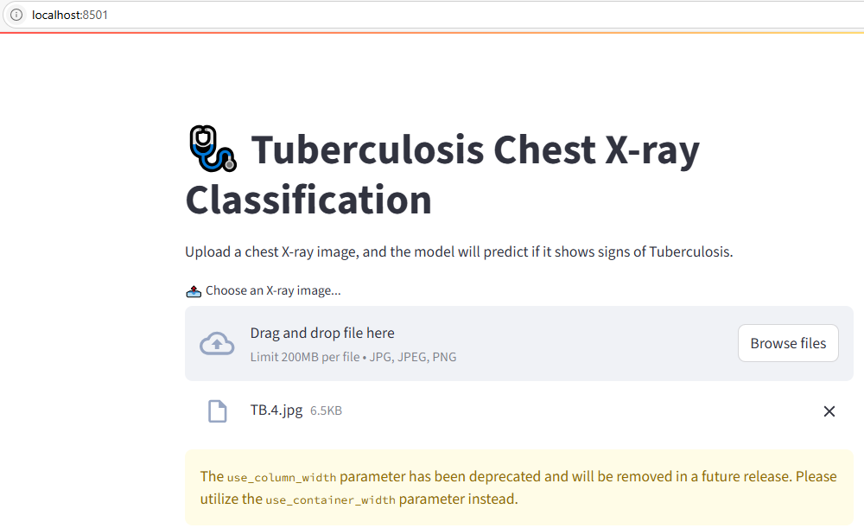
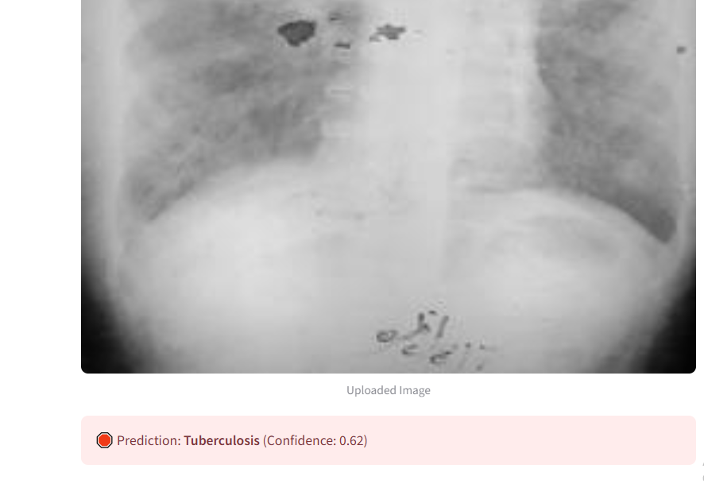
Before deployment, the application was tested locally to ensure functionality. Using the streamlit run app.py command, the app could be launched in a browser. Different test images, including normal and TB X-rays, were uploaded to verify that the model predictions were accurate.
Step 7: Deployment to AWS
Launched EC2 instance and established SSH connection
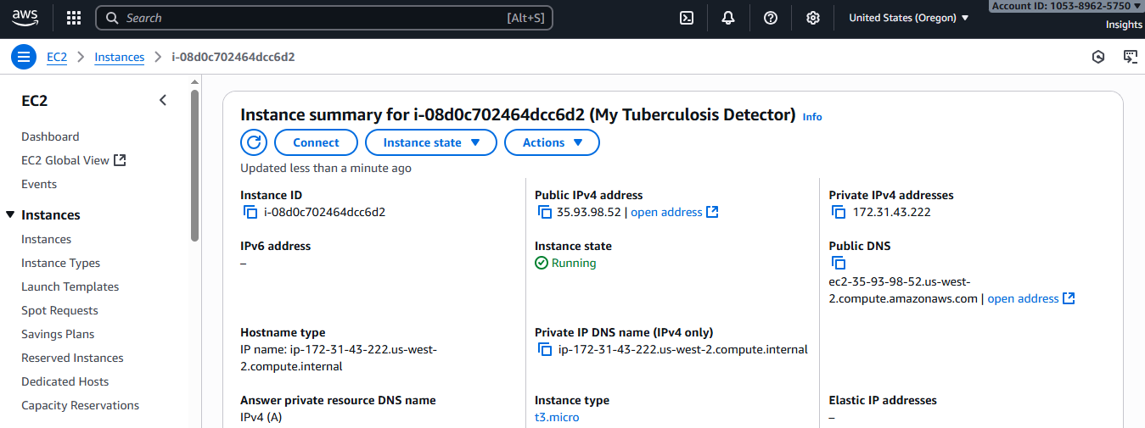
Installed necessary packages, set up Python, Streamlit, and deploy your TB X-ray model.
In a separate command prompt, downloaded the files
scp -i "C:/Users/LENOVO/Documents/Data Science Project/Mini Project 5 - DS_Tuberculosis Detection/my-ec2-keypair.pem" "C:/Users/LENOVO/Documents/Data Science Project/Mini Project 5 - DS_Tuberculosis Detection/TB_Xray_App/*" ubuntu@35.93.98.52:/home/ubuntu/

ssh -i "C:/Users/LENOVO/Documents/Data Science Project/Mini Project 5 - DS_Tuberculosis Detection/my-ec2-keypair.pem" ubuntu@35.93.98.52

App via AWS EC2 instance: http://35.93.98.52:8501
To make the application accessible over the web, an AWS EC2 Ubuntu instance was launched. Python and necessary dependencies were installed within a virtual environment. The application files, including the saved model, were securely copied to the instance using scp. Security group rules were configured to allow inbound TCP traffic on port 8501, the default Streamlit port. Finally, the Streamlit app was launched on the server, binding to 0.0.0.0 to accept connections from all IP addresses. The application became accessible via the EC2 public IP address, allowing users to interact with it remotely.
Launched the app on browser:
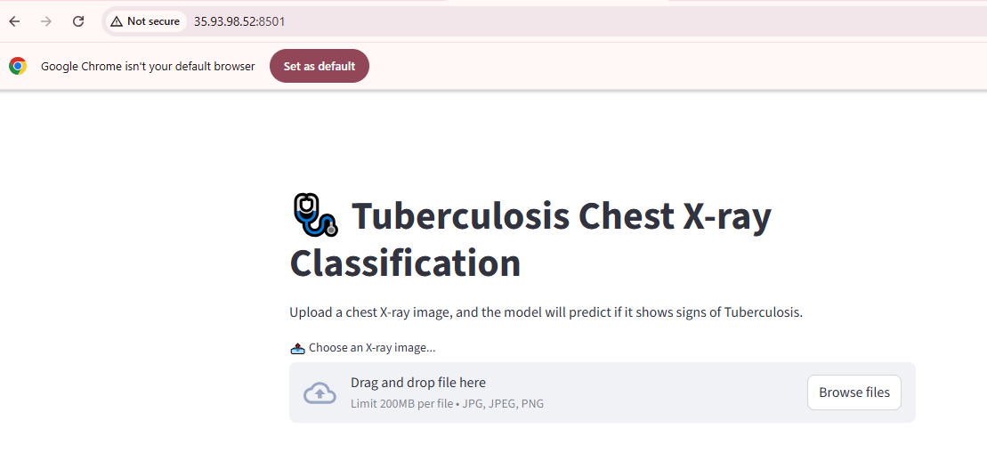
Uploaded a TB image
Result:
